DATA ANALYTICS CAPSTONE PROJECT REPORT

From cash to click: A data-driven analysis of India's digital payments transformation
(RBI bank-wise ATM / POS / Card statistics (2022–2025))

Prepared by: Nisiya Riju
Dataset period: March 2022 – September 2025
Report date: 02 September 2026

1. INTRODUCTION
India's retail payments landscape has shifted rapidly since 2022, moving away from cash-based ATM and POS usage toward card- and QR-based digital payments. The Reserve Bank of India (RBI) publishes monthly, bank-wise statistics covering ATM/CRM infrastructure, POS and QR (Bharat QR / UPI QR) infrastructure, credit- and debit-card issuance, and the volume and value of card-based transactions across payment channels (POS, online and other) and cash withdrawals. This report documents a complete data analytics workflow — data cleaning, feature engineering, exploratory data analysis, and interpretation — performed on the RBI bank-wise dataset for the period March 2022 to September 2025, to understand how physical banking infrastructure, digital payment infrastructure, and card-based transaction activity have evolved across five categories of Indian banks: Public Sector, Private Sector, Foreign, Small Finance and Payment Banks.

2. OBJECTIVES
1.Clean and prepare the raw RBI data into an analysis-ready, consistent dataset.
2.Engineer summary indicators (total infrastructure, total cards, total transaction volume/value) that answer business questions more directly than the raw, channel-level columns.
3.Explore the distribution, trends and relationships in the data using univariate, bivariate, multivariate, time-series, category-level and bank-level analysis.
4.Identify significant patterns, correlations and anomalies in banking infrastructure and digital payment adoption.
5.Summarize the findings into actionable insights and recommendations on India's shift from cash to digital payments.

3. DATASET DESCRIPTION
The raw file contains 2,671 monthly bank-level records across 30 columns, covering 67 unique banks grouped into 5 bank categories (Public Sector,Private Sector, Foreign, Small Finance and Payment Banks), over 43 months from March 2022 to September 2025. Each row represents one bank's activity in one calendar month — the dataset is structured as a bank × month panel, which is why grouping by bank_name, bank_category and date/year is used throughout the analysis to answer different questions. Section 5.3 of this report (Feature Engineering) adds derived "total" columns on top of this raw structure (e.g. total_cards, total_atms_crms, total_cc_payment_value) so that later analysis can work with whole-portfolio figures instead of repeatedly summing channel-level columns. After cleaning and feature engineering, the analysis-ready dataset expands to 42 columns while retaining all 2,671 records.

Dataset Column Groups

Group | Example Columns | What It Measures
Identifiers | id, date, bank_category, bank_name | Which bank, category, and month a row belongs to
Physical Infrastructure | atms_crms_onsite, atms_crms_offsite, pos, micro_atms | Number of ATM/CRM and POS/micro-ATM terminals deployed
Digital QR Infrastructure | bharat_qr, upi_qr | Number of QR-code payment access points deployed
Card Base | credit_cards, debit_cards | Number of cards issued and outstanding
Credit-Card Transactions | cc_pay_trns_*_vol, cc_pay_trns_*_val, cc_cash_withdraw_atm_* | Volume and value of credit-card payments and ATM cash withdrawals
Debit-Card Transactions | dc_pay_trns_*_vol, dc_pay_trns_*_val, dc_cash_withdraw_* | Volume and value of debit-card payments and cash withdrawals through ATM and POS

4. METHODOLOGY
4.1 Data loading and initial data overview
The dataset is loaded with pandas' read_excel() and inspected using head(), tail(), info() and describe(). head() and tail() confirm the general shape and formatting of the raw data by sampling its first and last records. info() reports the data type and non-null count of every column in a single call, which is the fastest way to spot columns needing type conversion or missing-value treatment. describe() is used specifically — rather than computing statistics manually — because it returns count, mean, standard deviation, minimum, quartiles and maximum for every numeric column in one comparable table, making it quick to notice extreme ranges or skew before any cleaning takes place. nunique() is also used to count distinct banks, categories and months, confirming the scope of the bank × month panel before deeper analysis begins. A quick visual check of missingness was added to complement the printed null counts, since a chart makes it easier to see at a glance which columns are affected and how their missingness compares in scale. This missing-value bar chart was added directly to the notebook as it did not previously exist as a visual check; null values were found only in atms_crms_onsite (7 rows), atms_crms_offsite (16 rows), and eight credit-card transaction columns (2 rows each).

4.1.1 Load
**********************************************************************************
import pandas as pd
import numpy as np
import matplotlib.pyplot as plt
import seaborn as sns
**********************************************************************************

4.1.2 Initial data overview
The initial inspection is performed to understand the structure and quality of the dataset. The head(), tail(), info(), and describe() functions are used to examine sample records, data types, missing values, numerical distributions, and statistical characteristics such as minimum, maximum, mean and standard deviation.
**********************************************************************************
df = pd.read_excel("Bankwise-ATM-POS-Card-statistics (2022-2025) - Dataset.xlsx", sheet_name=0)
print("Shape before cleaning:", df.shape)
print("\nNull values per column:\n", df.isnull().sum()[df.isnull().sum() > 0])
print("\nExact duplicate rows:", df.duplicated().sum())
print("Duplicate (date, bank_name) combos:",
df.duplicated(subset=["date", "bank_name"]).sum())
df.info()
display(df.head())
display(df.tail())
display(df.describe().T)
**********************************************************************************

4.2 Dataset Dimensions
The dataset consists of monthly observations from multiple banking institutions.The analysis identifies the number of unique banks, banking categories and months available in the dataset. This provides an understanding of the scope and coverage of the data before performing detailed analysis.

**********************************************************************************
print("Total Records:", len(df))
print("Total Features:", df.shape[1])

print("Unique Banks:", df["bank_name"].nunique())
print("Bank Categories:", df["bank_category"].nunique())
print("Number of Months:", df["date"].nunique())

print("\nBank Categories:")
print(df["bank_category"].unique())

print("\nDate Range:")
print(df["date"].min(), "to", df["date"].max())
**********************************************************************************
4.3 Data Cleaning
The raw data is cleaned so that later aggregations and charts are not distorted by duplicate entities, missing values, or incorrect data types. Cleaning follows a fixed order: (1) standardize categorical labels, (2) treat missing values based on why they are missing rather than a single default rule, (3) correct data types, (4) detect — but not blindly remove — outliers, and (5) run sanity checks. This order matters: for example, fixing bank names before grouping avoids creating a false duplicate bank, and filling missing values before casting to int64 avoids a type-conversion error, since integers cannot hold missing values.
Issue found | Treatment applied | Why
"Catholic Syrian Bank" and "CSB Bank" are the same institution | Standardized to "CSB Bank" via an explicit .replace() mapping | Prevents the same bank from being split into two entities during grouping/aggregation
Missing atms_crms_onsite / atms_crms_offsite (23 rows) | Filled with 0 | Absence of reported infrastructure is a structural zero, not an unknown value
Missing cc_ columns for India Post Payments Bank, Mar–Apr 2022 (2 rows) | Filled with 0 | Payments Banks are not RBI-licensed to issue credit cards, so these are structural zeros
cc_ / atms_ columns upcast to float64 | Cast back to int64 after nulls were filled | These are physical counts and transaction volumes, which should not display as decimals
Potential outliers in every numeric column (IQR test) | Retained, not removed | Outliers most likely reflect genuine differences in bank operating scale rather than data errors
Duplicate rows / bank-category mismatches / whitespace | Verified as zero via sanity checks | Confirms the cleaned data is safe to aggregate without hidden duplication

4.3.1 Standardize Bank Names¶
Inconsistent naming of the same bank can create duplicate entities during grouping and aggregation.During data inspection, Catholic Syrian Bank andCSB Bank were identified as two names referring to the same institution.Therefore, Catholic Syrian Bank is standardized to CSB Bank. This ensures that all monthly observations belonging to the same bank are treated as a single entity during subsequent analysis.
**********************************************************************************
df["bank_name"] = df["bank_name"].replace(
{"Catholic Syrian Bank": "CSB Bank"})
**********************************************************************************
4.3.2 Handle Missing Values
4.3.2.1 ATMS_CRMS_ONSITE and ATMS_CRMS_OFFSITE
The columns atms_crms_onsite and atms_crms_offsite contain a small number of missing values.Based on the structure of the dataset, these missing values occur for banks where the corresponding ATM/CRM infrastructure was not reported or was not applicable for that observation.Since the variable represents the number of physical ATM/CRM units, the absence of reported infrastructure is treated as zero.Therefore, missing values in these columns are replaced with 0.
**********************************************************************************
atm_cols = ["atms_crms_onsite", "atms_crms_offsite"]
df[atm_cols] = df[atm_cols].fillna(0)
**********************************************************************************
4.3.2.2 Credit Card columns for India Post Payments Bank (Mar & Apr 2022)
Missing values were also identified in the credit-card transaction variables.Payments Banks are not RBI-licensed to issue credit cards, the missing values represent structural zeros rather than missing measurements.Therefore, these missing values are replaced with 0.This treatment is appropriate because replacing these observations with statistical estimates such as the mean or median would incorrectly imply that credit-card activity existed for those bank-month observations.

**********************************************************************************
cc_cols = [c for c in df.columns if c.startswith("cc_")]
df[cc_cols] = df[cc_cols].fillna(0)
print("\nNull values after cleaning:", df.isnull().sum().sum())
**********************************************************************************
4.3.3 Correct Data Types
Several cc_/atms_ columns were upcast to float64 because of the NaN values. Now that nulls are filled, cast counts back to integer types for consistency with their dc_ counterparts. Missing values can cause numerical count variables to be automatically stored as float64.After missing values have been handled, count-based variables are converted back to integer data types. The following variables are treated as integer-like measures:
- ATM/CRM counts
- Credit-card transaction volumes
- Credit-card ATM withdrawal volumes Correct data types improve consistency, memory efficiency and interpretation of the dataset.

**********************************************************************************
int_like_cols = [
"atms_crms_onsite", "atms_crms_offsite",
"cc_pay_trns_at_pos_vol", "cc_pay_trns_online_vol", "cc_pay_trns_other_vol",
"cc_cash_withdraw_atm_vol",
]
for c in int_like_cols:
df[c] = df[c].astype("int64")
**********************************************************************************
4.3.4 Detect Outliers - IQR Outlier Analysis
The Interquartile Range (IQR) method is used to identify potential outliers in the numerical variables of the dataset. Q1 and Q3 are calculated for each variable, and the IQR is calculated as the difference between Q3 and Q1. The lower and upper limits are determined using 1.5 times the IQR. Values outside these limits are considered potential outliers.
Key findings:-
The IQR and box plot analysis identified potential outliers in several numerical variables. These extreme observations indicate variation in banking infrastructure, card usage and transaction activity across the dataset. The outliers were retained because they may represent genuine differences in the operational scale of banks rather than data errors.
**********************************************************************************
# Select all numerical columns except 'id'
numeric_columns = df.select_dtypes(include='number').columns.drop('id', errors='ignore')

# IQR Test
iqr_results = []
for column in numeric_columns:
Q1 = df[column].quantile(0.25)
Q3 = df[column].quantile(0.75)

IQR = Q3 - Q1

lower_limit = Q1 - 1.5 * IQR
upper_limit = Q3 + 1.5 * IQR
outlier_count = (
(df[column] < lower_limit) |
(df[column] > upper_limit)
).sum()
iqr_results.append({
"Column": column,
"Q1": Q1,
"Q3": Q3,
"IQR": IQR,
"Lower Limit": lower_limit,
"Upper Limit": upper_limit,
"Outlier Count": outlier_count
})
# Convert results into DataFrame
iqr_results_df = pd.DataFrame(iqr_results)

# Display IQR results
display(iqr_results_df)
**********************************************************************************
# Highest outlier count
highest_outlier = iqr_results_df.loc[
iqr_results_df["Outlier Count"].idxmax()
]

# Lowest outlier count
lowest_outlier = iqr_results_df.loc[
iqr_results_df["Outlier Count"].idxmin()
]

print("HIGHEST OUTLIER COUNT")
print("Column:", highest_outlier["Column"])
print("Outlier Count:", highest_outlier["Outlier Count"])

print("\nLOWEST OUTLIER COUNT")
print("Column:", lowest_outlier["Column"])
print("Outlier Count:", lowest_outlier["Outlier Count"])
**********************************************************************************
plt.figure(figsize=(15, 7))
sns.boxplot(data=df[numeric_columns])
plt.title("Box Plot of Numerical Variables")
plt.xlabel("Variables")
plt.ylabel("Values")
plt.xticks(rotation=45)
plt.tight_layout()
plt.show()
**********************************************************************************
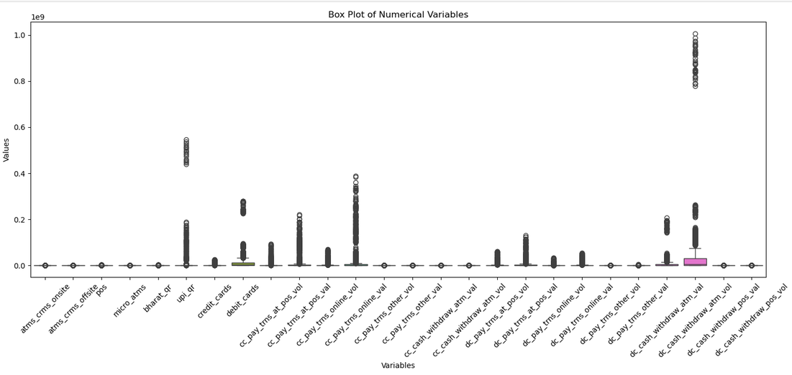

4.3.5 Sanity Check
**********************************************************************************
num_cols = df.select_dtypes(include="number").columns.drop("id")
neg_counts = (df[num_cols] < 0).sum()
print("\nColumns with negative values (should be none):\n",
neg_counts[neg_counts > 0])
ws_issues = (df["bank_name"] != df["bank_name"].str.strip()).sum()
print("bank_name whitespace issues:", ws_issues)

multi_cat = df.groupby("bank_name")["bank_category"].nunique()
print("Banks mapped to >1 category (should be none):\n",
multi_cat[multi_cat > 1])
**********************************************************************************
4.3.6 CONVERT COLUMN TITLES TO UPPERCASE
**********************************************************************************
df.columns = df.columns.str.upper()
print("\nColumn titles after conversion:\n", df.columns.tolist())

print("\nShape after cleaning:", df.shape)
df.to_csv("bankwise_atm_pos_card_cleaned.csv", index=False)
**********************************************************************************
5. Feature Engineering
The raw dataset separates every metric into fine-grained components (e.g. onsite vs offsite ATMs, POS vs online vs other transaction channels). These are combined into single "total" measures total ATM/CRM network, total QR infrastructure, total cards, total credit-card and debit-card payment volume value, and total cash withdrawal volume/value, because the business questions in this project (overall infrastructure scale, overall card adoption, overall transaction activity) concern the whole picture, not individual channels. Building these totals once avoids repeating the same addition inside every later chart. year, month and month_name are also extracted from date using pandas' .dt accessor so the data can be grouped by calendar period for the time-series analysis in Section 7.
**********************************************************************************
# Year and Month
df["year"] = df["date"].dt.year
df["month"] = df["date"].dt.month
df["month_name"] = df["date"].dt.strftime("%b")
# Total ATM/CRM Network
df["total_atms_crms"] = (
df["atms_crms_onsite"] +
df["atms_crms_offsite"])
# Total Digital QR Infrastructure
df["total_qr"] = (
df["bharat_qr"] +
df["upi_qr"])
# Total Cards
df["total_cards"] = (
df["credit_cards"] +
df["debit_cards"])
# Total Credit Card Payment Volume
df["total_cc_payment_volume"] = (
df["cc_pay_trns_at_pos_vol"] +
df["cc_pay_trns_online_vol"] +
df["cc_pay_trns_other_vol"])
# Total Credit Card Payment Value
df["total_cc_payment_value"] = (
df["cc_pay_trns_at_pos_val"] +
df["cc_pay_trns_online_val"] +
df["cc_pay_trns_other_val"])
# Total Debit Card Payment Volume
df["total_dc_payment_volume"] = (
df["dc_pay_trns_at_pos_vol"] +
df["dc_pay_trns_online_vol"] +
df["dc_pay_trns_other_vol"])
# Total Debit Card Payment Value
df["total_dc_payment_value"] = (
df["dc_pay_trns_at_pos_val"] +
df["dc_pay_trns_online_val"] +
df["dc_pay_trns_other_val"])
# Total Cash Withdrawal Volume
df["total_cash_withdrawal_volume"] = (
df["cc_cash_withdraw_atm_vol"] +
df["dc_cash_withdraw_atm_vol"] +
df["dc_cash_withdraw_pos_vol"])
# Total Cash Withdrawal Value
df["total_cash_withdrawal_value"] = (
df["cc_cash_withdraw_atm_val"] +
df["dc_cash_withdraw_atm_val"] +
df["dc_cash_withdraw_pos_val"])
**********************************************************************************
6.Final Clean Dataset
**********************************************************************************
print("Final dataset shape:", df.shape)
print("\nRemaining missing values:",
df.isnull().sum().sum())
display(df.head())

df.to_csv(
"bankwise_atm_pos_card_cleaned.csv",
index=False)
**********************************************************************************

7. Exploratory Data Analysis (EDA)
Exploratory Data Analysis is performed to understand the patterns, distributions, relationships and trends present in the cleaned dataset. The analysis uses both statistical methods and visualizations to explore banking infrastructure, card adoption, digital payment infrastructure and transaction activity.
The EDA is organized into eight categories :
- Univariate Analysis
- Bivariate Analysis
- Multivariate Analysis
- Time-Series Analysis
- Category-Level Analysis
- Bank-Level Ranking Analysis
- Correlation Analysis
- Composition Analysis,
because each answers a different kind of question: univariate analysis describes a single variable's shape; bivariate/multivariate analysis look at relationships between variables; time-series analysis looks at change over the study period; category- and bank-level analysis identify who is driving the numbers; correlation analysis quantifies relationships across many variables at once; and composition analysis breaks a total into its channel-level parts. The table below summarizes every chart used in this project and the reasoning behind the chart-type choice, followed by a chart-by-chart discussion with the actual figures produced.
7.1. Credit Card Distribution - Univariate Analysis
Chart type: Histogram with KDE overlay
A Histogram with KDE was selected to understand the distribution of credit card values across the dataset. It shows how frequently different value ranges occur and helps identify the concentration, spread, shape, and skewness of the data. This provides more detailed information about the distribution than summary statistics alone. A histogram is the standard way to examine the distribution of a single continuous variable, since it directly shows how frequently different ranges of values occur — exactly what is needed to see concentration, spread and skewness, none of which are visible from summary statistics alone.
Key findings:- Credit-card holdings range from 0 to 25,285,047 cards. The median is 11,610 cards while the mean is approximately 1.54 million — since the mean is far higher than the median, the distribution is strongly right-skewed, with a small number of bank-month observations reporting exceptionally high credit-card holdings.
**********************************************************************************
plt.figure(figsize=(10, 6))
sns.histplot(
data=df,
x="credit_cards",
bins=40,
kde=True
)
plt.title("Distribution of Credit Cards")
plt.xlabel("Number of Credit Cards")
plt.ylabel("Frequency")

plt.tight_layout()
plt.show()
**********************************************************************************

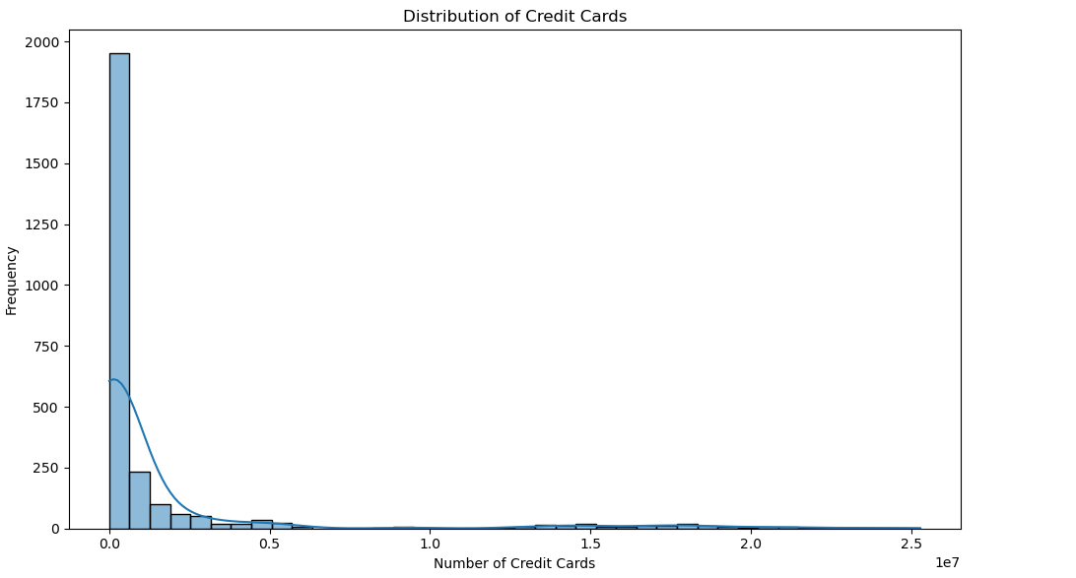

7.2.ATM/CRM Infrastructure by Bank Category - GroupBy Analysis
Chart type: Vertical bar chart
The dataset is grouped by bank category and the total ATM/CRM infrastructure is calculated for each category. A bar chart is then used to compare physical banking infrastructure across different banking segments. Bank_category is a small set of discrete groups, and the goal is to compare one summed quantity (total ATM/CRM units) across those groups; bar length is the most immediately readable way to compare magnitudes across a handful of categories.
Key findings:- Public Sector Banks recorded the highest total ATM/CRM infrastructure (5,828,966 units), followed by Private Sector Banks (3,304,972 units), Small Finance Banks (123,727 units), Foreign Banks (55,124 units) and Payment Banks (1,099 units). Public Sector Banks therefore maintained approximately 1.76× the ATM/CRM infrastructure of Private Sector Banks.
**********************************************************************************
atm_category = (
df.groupby("bank_category")["total_atms_crms"]
.sum()
.sort_values(ascending=False)
)
plt.figure(figsize=(10, 6))
plt.bar(
atm_category.index,
atm_category.values
)
plt.title("Total ATM/CRM Infrastructure by Bank Category")
plt.xlabel("Bank Category")
plt.ylabel("Total ATMs/CRMs")
plt.xticks(rotation=45)
plt.tight_layout()
plt.show()
**********************************************************************************
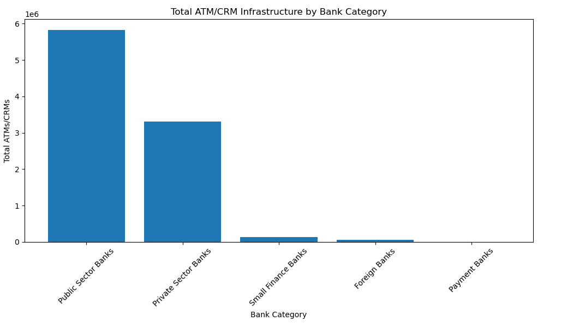
7.3.Digital Payment Infrastructure - Multivariate Analysis
Chart type: Multi-series (grouped) bar chart
Multiple digital payment infrastructure variables are compared across bank categories. POS terminals, Micro ATMs, Bharat QR and UPI QR are analyzed simultaneously to understand differences in digital payment infrastructure. Four different infrastructure variables (POS, micro-ATMs, Bharat QR, UPI QR) need to be compared side-by-side within each bank category; plotting all four as separate bars per category makes both the category-level pattern and the mix of infrastructure types visible in one view.
Observation:- Private Sector Banks account for approximately 90.88% of the total UPI QR infrastructure recorded in the dataset, indicating a substantially larger reported UPI QR presence compared with the other bank categories.
**********************************************************************************
digital_infrastructure = (
df.groupby("bank_category")[
["pos", "micro_atms", "bharat_qr", "upi_qr"]
]
.sum()
)

digital_infrastructure.plot(
kind="bar",
figsize=(14, 7)
)

plt.title("Digital Payment Infrastructure by Bank Category")
plt.xlabel("Bank Category")
plt.ylabel("Infrastructure Units")

plt.xticks(rotation=45)
plt.legend(title="Infrastructure Type")

plt.tight_layout()
plt.show()
**********************************************************************************
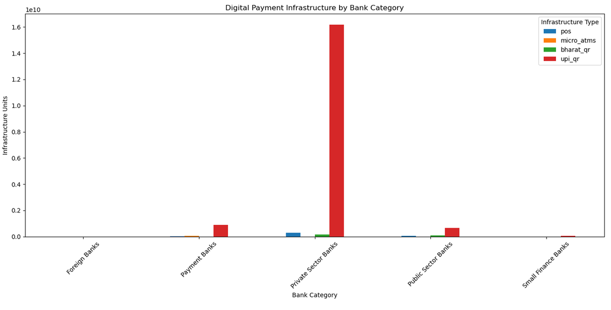

7.4.Card Adoption (Credit Card vs Debit Card) - Multivariate Analysis
Chart type: Grouped bar chart
Credit-card and debit-card holdings are aggregated by bank category and compared using a grouped bar chart. This analysis identifies differences in card adoption and card portfolio composition across banking segments. A grouped bar chart lets credit-card and debit-card totals be compared directly, category by category, in a single chart rather than requiring two separate charts to be mentally combined.
Key findings:- Private Sector Banks contributed approximately 69.92% of credit-card holdings in the dataset, while Public Sector Banks contributed approximately 66.14% of debit-card holdings — a clear divergence in which segment leads which card type.

**********************************************************************************
card_category = (
df.groupby("bank_category")[
["credit_cards", "debit_cards"]
]
.sum()
)

card_category.plot(
kind="bar",
figsize=(12, 7)
)

plt.title("Credit Card vs Debit Card by Bank Category")
plt.xlabel("Bank Category")
plt.ylabel("Number of Cards")

plt.xticks(rotation=45)
plt.legend(title="Card Type")

plt.tight_layout()
plt.show()
**********************************************************************************
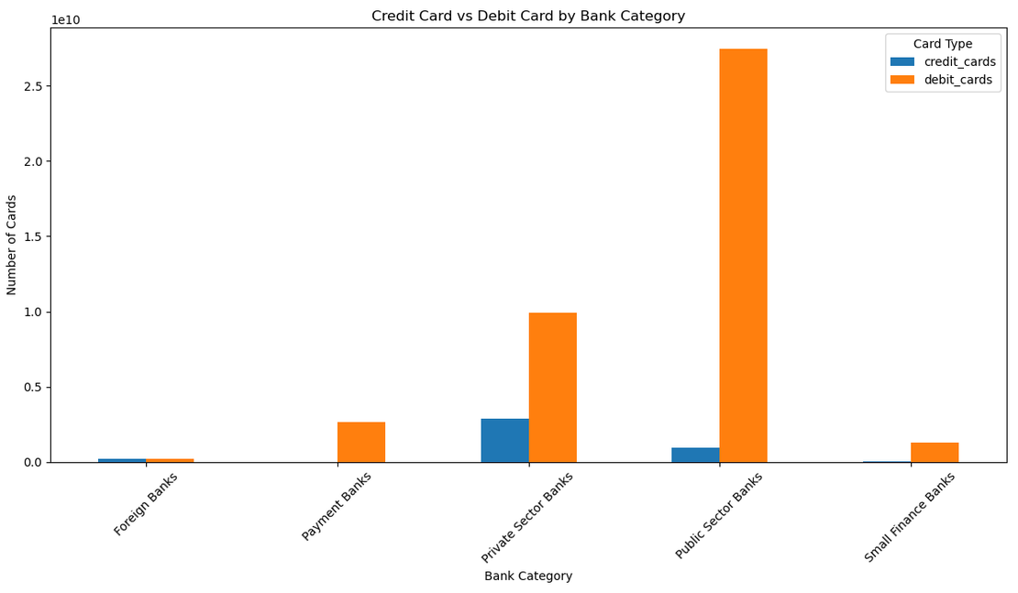

7.5.Yearly Credit Card & Debit Card Trend - Time-Series Analysis
Chart type: Line chart
The yearly trend of credit-card and debit-card holdings is analyzed to identify changes in card adoption from 2022 to 2025. The line chart makes it possible to observe the direction and rate of change over time. Year is an ordered, continuous axis, and the objective is to see the direction and rate of change of card holdings over time; a line chart makes the trend and any change in slope immediately visible in a way a bar chart does not.
Key findings:- Credit-card holdings rose from 781.5 million (2022) to 1,076.8 million (2023) and 1,249.8 million (2024) — a 37.79% then 16.06% year-on-year increase. Debit-card holdings rose from 9.30 billion (2022) to 11.62 billion (2023), then plateaued at 11.61 billion in 2024 (a 0.11% decline). 2025 values are lower only because the dataset runs through September 2025 and should not be compared directly to a complete year.
**********************************************************************************
yearly_cards = (
df.groupby("year")[["credit_cards", "debit_cards"]]
.sum()
)

plt.figure(figsize=(12, 6))

plt.plot(
yearly_cards.index,
yearly_cards["credit_cards"],
marker="o",
label="Credit Cards"
)

plt.plot(
yearly_cards.index,
yearly_cards["debit_cards"],
marker="o",
label="Debit Cards"
)

plt.title("Yearly Credit Card and Debit Card Trend")
plt.xlabel("Year")
plt.ylabel("Number of Cards")
plt.legend()

plt.tight_layout()
plt.show()
**********************************************************************************
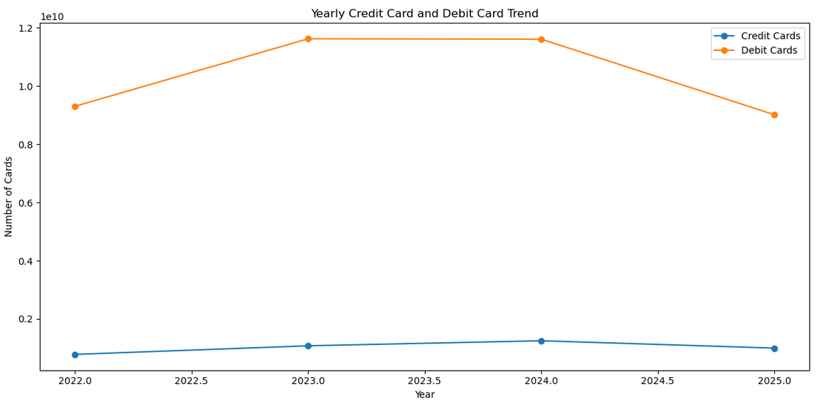

7.6.Monthly UPI QR Trend - Time-Series Analysis
Chart type: Line chart
Monthly UPI QR infrastructure is analyzed to understand the development of QR-based digital payment infrastructure throughout the 2022–2025 period. Tracking one metric (UPI QR infrastructure) continuously at monthly granularity is the natural way to read the overall growth trajectory and its pace across the full study period.
Key findings:- Total UPI QR infrastructure increased from 172,733,615 units in March 2022 to 709,065,908 units in September 2025 — an increase of approximately 410.5% over the observed period, with September 2025 recording the dataset's highest monthly value.
**********************************************************************************
monthly_upi = (
df.groupby("date")["upi_qr"]
.sum()
)

plt.figure(figsize=(14, 6))

plt.plot(
monthly_upi.index,
monthly_upi.values,
marker="o"
)

plt.title("Monthly UPI QR Infrastructure Trend")
plt.xlabel("Date")
plt.ylabel("UPI QR Units")

plt.xticks(rotation=45)

plt.tight_layout()
plt.show()
**********************************************************************************
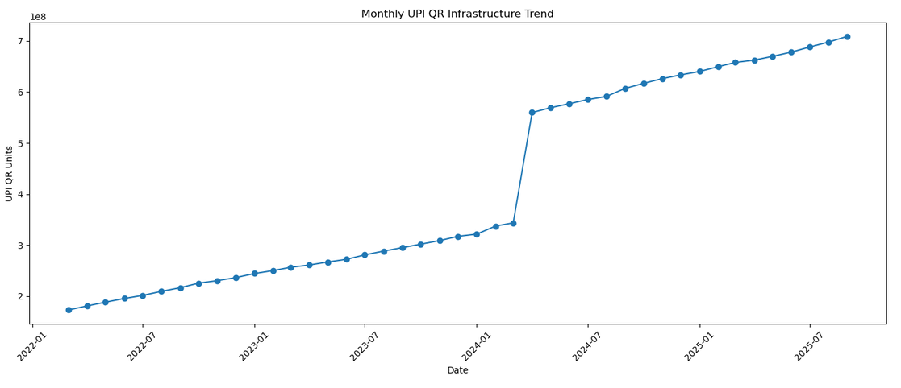

7.7.Top 10 Banks by Total Cards - Bank-Level Ranking
Chart type: Horizontal bar chart
Banks are grouped and ranked according to their combined credit-card and debit-card holdings. A horizontal bar chart is used to clearly compare the ten banks with the largest card portfolios. Bank names are long text labels that read far better horizontally than rotated on a vertical axis, and horizontal bars naturally read top-to-bottom as a ranking, which matches the purpose of this chart.
Key findings:- State Bank of India ranked first with 11,658,559,698 total cards, approximately 3.11× the total of second-ranked Bank of Baroda (3,752,290,854). HDFC Bank ranked third (3,162,770,392) and Canara Bank fourth (2,389,219,509); Kotak Mahindra Bank recorded the lowest total among the top 10 (1,555,288,962).
**********************************************************************************
top_10_cards = (
df.groupby("bank_name")["total_cards"]
.sum()
.sort_values(ascending=False)
.head(10)
)
plt.figure(figsize=(12, 7))

plt.barh(
top_10_cards.index[::-1],
top_10_cards.values[::-1]
)

plt.title("Top 10 Banks by Total Cards")
plt.xlabel("Total Cards")
plt.ylabel("Bank")
plt.tight_layout()
plt.show()
**********************************************************************************
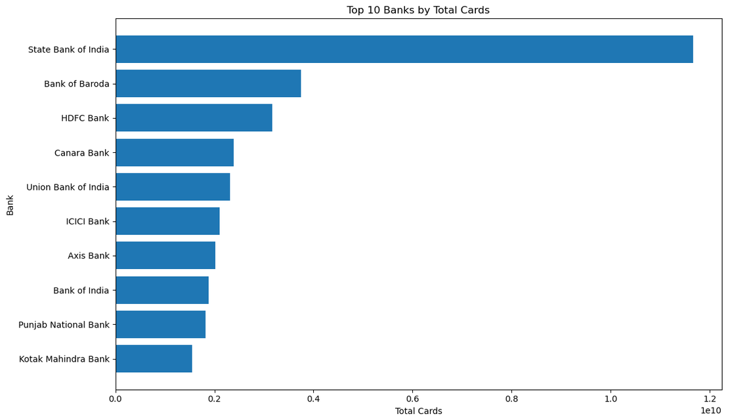

7.8.Top 10 Banks by UPI QR - Bank-Level Ranking
Chart type: Horizontal bar chart
Banks are grouped according to their total UPI QR infrastructure and ranked to identify the ten banks with the largest reported QR-based payment infrastructure.The same horizontal-bar ranking approach is used again for consistency and readability, this time for UPI QR infrastructure.
Key findings:- Yes Bank recorded the highest UPI QR infrastructure (12,395,779,803 units), approximately 3.92× that of second-ranked Axis Bank (3,165,091,153) and about 71.55% of the combined total among the top 10 banks. Paytm Payments Bank ranked third (731,277,457) and Indian Bank ranked tenth (98,048,576).
**********************************************************************************
top_10_upi = (
df.groupby("bank_name")["upi_qr"]
.sum()
.sort_values(ascending=False)
.head(10)
)
plt.figure(figsize=(12, 7))

plt.barh(
top_10_upi.index[::-1],
top_10_upi.values[::-1]
)
plt.title("Top 10 Banks by UPI QR Infrastructure")
plt.xlabel("UPI QR Units")
plt.ylabel("Bank")

plt.tight_layout()
plt.show()
**********************************************************************************
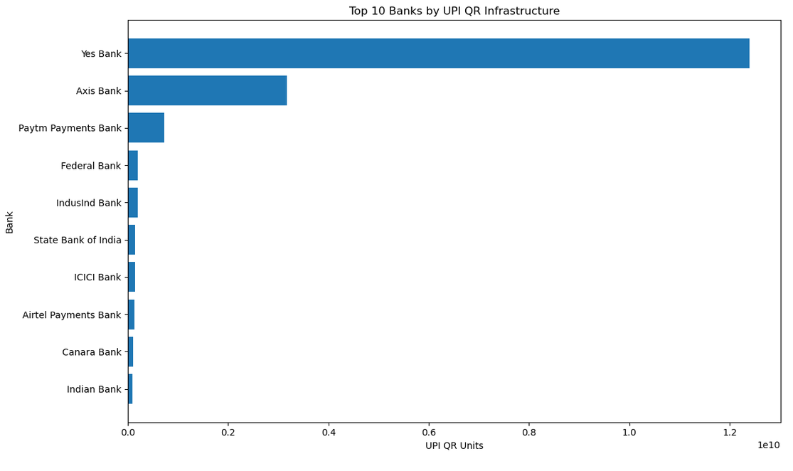

7.9.Credit Card Transaction Channels - Composition Analysis
Chart type: Pie chart
Credit-card transaction volume is divided into POS, online and other channels. A pie chart is used to show the relative contribution of each transaction channel.The three transaction channels (POS, online, other) are mutually exclusive parts of one whole (100% of transaction volume); a pie chart is the standard way to show how a total splits into its parts for a small number of categories.
Key findings:- POS transactions accounted for 51.83% of total credit-card payment volume and online transactions 48.09% — a difference of only about 3.74 percentage points, showing both channels contribute substantially. Other channels accounted for a negligible 0.08%.
**********************************************************************************
cc_channels = {
"POS": df["cc_pay_trns_at_pos_vol"].sum(),
"Online": df["cc_pay_trns_online_vol"].sum(),
"Other": df["cc_pay_trns_other_vol"].sum()
}
plt.figure(figsize=(8, 8))

plt.pie(
cc_channels.values(),
labels=cc_channels.keys(),
autopct="%1.1f%%",
startangle=90
)
plt.title("Credit Card Transaction Volume by Channel")
plt.show()
**********************************************************************************
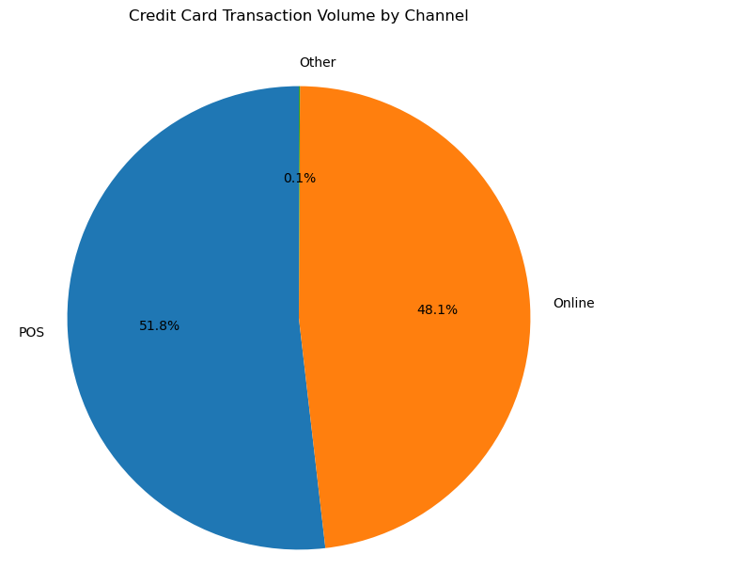

7.10.Debit Card Transaction Channels - Composition Analysis
Chart type: Pie chart
Debit-card transaction volumes are divided into POS, online and other channels to understand the composition of debit-card payment activity.The same composition logic applies to debit-card channels, keeping the two card types visually comparable using the same chart type.
Key findings:- Debit-card transactions were predominantly POS-based (70.30%), with online at 29.58% and other channels at only 0.11%. Compared to credit cards, debit-card activity shows a much stronger dependence on POS transactions
**********************************************************************************
dc_channels = {
"POS": df["dc_pay_trns_at_pos_vol"].sum(),
"Online": df["dc_pay_trns_online_vol"].sum(),
"Other": df["dc_pay_trns_other_vol"].sum()
}

plt.figure(figsize=(8, 8))

plt.pie(
dc_channels.values(),
labels=dc_channels.keys(),
autopct="%1.1f%%",
startangle=90
)
plt.title("Debit Card Transaction Volume by Channel")
plt.show()
**********************************************************************************
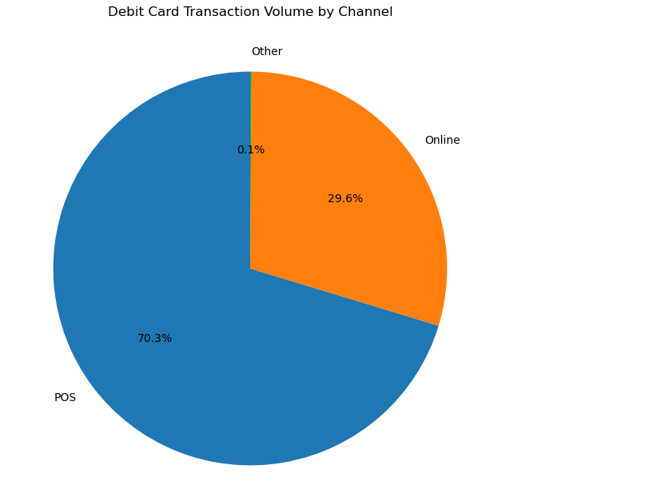

7.11. Credit Card vs Debit Card Transaction Value - Comparative Analysis
Chart type: Bar chart (2 categories)
The total transaction values of credit cards and debit cards are compared to determine the relative monetary contribution of the two card types during the study period. With only two categories to compare (credit vs debit card transaction value), a simple bar chart communicates the magnitude difference at a glance without the added complexity of a distribution or trend chart.
Key findings:- Credit-card transactions recorded a total reported value of ₹66,385,652,639.15 versus ₹20,952,587,836.88 for debit cards — credit cards therefore contributed approximately 76.01% of the combined value, roughly 3.17× the debit-card total.

**********************************************************************************
transaction_values = {
"Credit Card": df["total_cc_payment_value"].sum(),
"Debit Card": df["total_dc_payment_value"].sum()
}

plt.figure(figsize=(8, 6))

plt.bar(
transaction_values.keys(),
transaction_values.values()
)

plt.title("Credit Card vs Debit Card Transaction Value")
plt.xlabel("Card Type")
plt.ylabel("Total Transaction Value")

plt.tight_layout()
plt.show()
**********************************************************************************
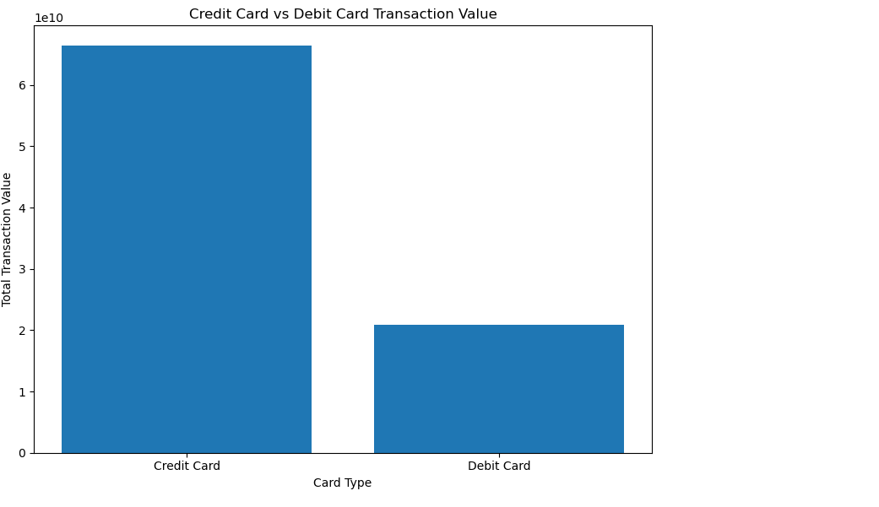

7.12.Total Cards vs Credit Card Transaction Value - Bivariate Analysis
Chart type: Scatter plot (with category hue)
A scatter plot is used to investigate the relationship between total card holdings and credit-card transaction value. Bank categories are represented separately to identify category-level patterns. A scatter plot is the correct choice for examining the relationship between two continuous variables, since it plots every bank-month observation as a point; colouring points by bank_category adds a third, categorical dimension without needing five separate charts.
Key findings:- The scatter plot shows a moderate positive relationship between total card holdings and credit-card transaction value — bank-month observations with larger card portfolios tend to report higher transaction values, though the relationship is not perfectly linear, indicating other factors also drive transaction value.
**********************************************************************************
plt.figure(figsize=(10, 6))

sns.scatterplot(
data=df,
x="total_cards",
y="total_cc_payment_value",
hue="bank_category",
alpha=0.6
)
plt.title(
"Relationship Between Total Cards and Credit Card Transaction Value"
)
plt.xlabel("Total Cards")
plt.ylabel("Credit Card Transaction Value")
plt.tight_layout()
plt.show()
**********************************************************************************
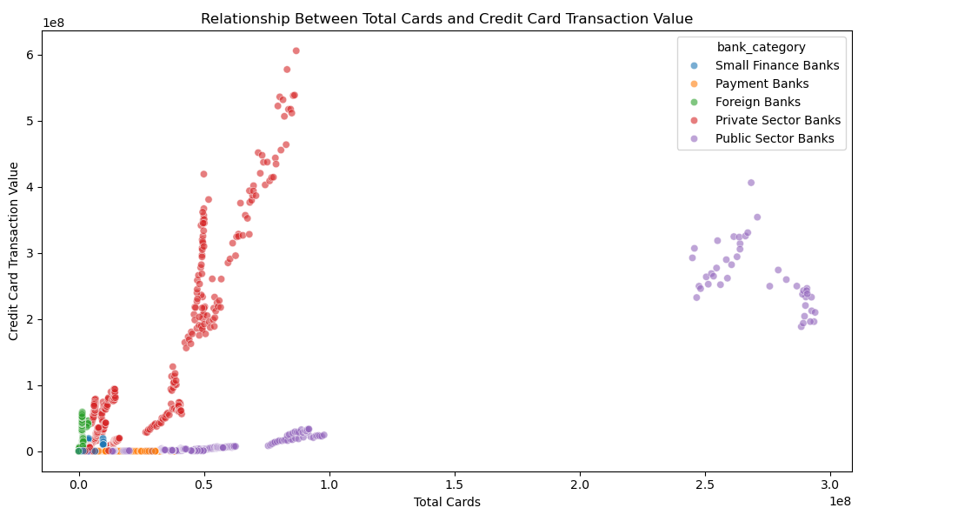

7.13. Credit Cards by Bank Category - Distribution and Outlier Analysis
Chart type: Box plot
A box plot is used to compare the distribution of credit-card holdings across bank categories. The visualization identifies differences in median, spread and potential outliers. A box plot shows the full distribution — median, interquartile spread and outliers — per category, not just a single average; this matters because credit-card holdings are already known (Section 4.2) to be highly skewed with outliers, so a mean-only chart would be misleading.
Key findings:- Public Sector Banks have the highest median credit-card holding (156,216), followed by Private Sector Banks (126,256.5) and Foreign Banks (21,893.5); Small Finance Banks have a median of 0, and Payment Banks show a median, mean and maximum of 0, since Payments Banks are not licensed to issue credit cards.
**********************************************************************************
plt.figure(figsize=(12, 7))
sns.boxplot(
data=df,
x="bank_category",
y="credit_cards"
)
plt.title("Credit Card Distribution by Bank Category")
plt.xlabel("Bank Category")
plt.ylabel("Number of Credit Cards")
plt.xticks(rotation=45)
plt.tight_layout()
plt.show()
**********************************************************************************
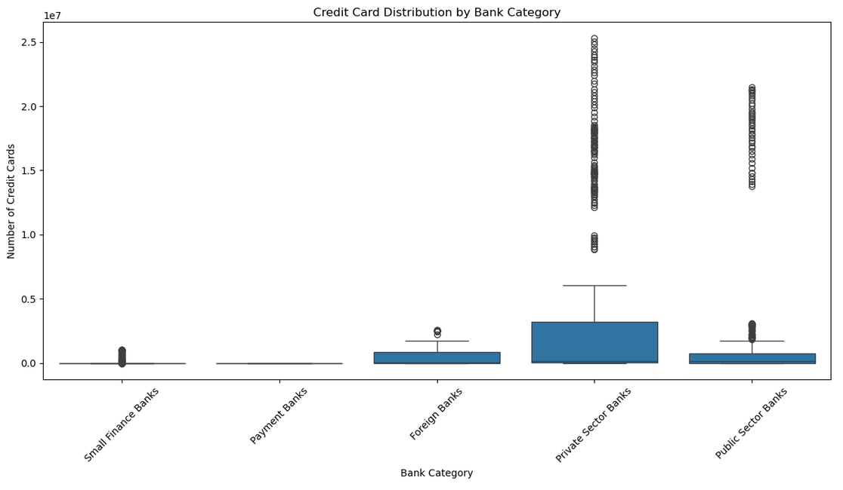

7.14. Correlation Matrix - Multivariate Correlation Analysis
Chart type: Heatmap
A correlation heatmap is used to examine the relationships among banking infrastructure, card holdings and transaction indicators. This provides a consolidated view of the strength and direction of linear relationships between multiple numerical variables. A heatmap lets many pairwise relationships (14×14 variables here) be scanned at once: colour intensity draws the eye to the strongest positive or negative relationships, while the numeric annotation still allows the exact coefficient to be read for any pair of interest.
Key findings:- Debit cards and total cards correlate at 0.996 (expected, since total cards is derived from both card types). Credit cards correlate strongly with credit-card payment volume (0.979) and value (0.975). ATM/CRM infrastructure correlates 0.968 with total cards. Total cards and credit-card transaction value correlate only moderately (0.596), showing that transaction value is influenced by more than card count alone — e.g. usage intensity or ticket size.
**********************************************************************************
correlation_cols = [
"total_atms_crms",
"pos",
"micro_atms",
"bharat_qr",
"upi_qr",
"credit_cards",
"debit_cards",
"total_cards",
"total_cc_payment_volume",
"total_cc_payment_value",
"total_dc_payment_volume",
"total_dc_payment_value",
"total_cash_withdrawal_volume",
"total_cash_withdrawal_value"
]
corr_matrix = df[correlation_cols].corr()

plt.figure(figsize=(14, 10))
sns.heatmap(
corr_matrix,
annot=True,
fmt=".2f",
cmap="coolwarm",
center=0
)
plt.title("Correlation Matrix of Banking and Payment Indicators")
plt.tight_layout()
plt.show()
**********************************************************************************
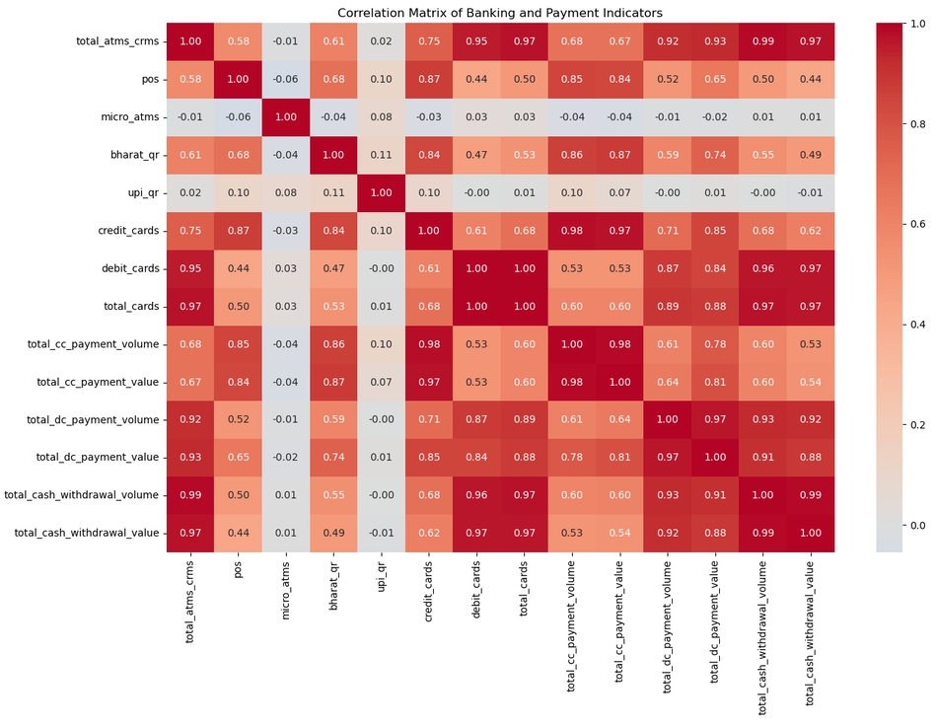

7.15. Cards and Credit Card Transaction Value - Combo Chart
Chart type: Dual-axis combination chart (bar + line)
A combination chart is used to compare total card holdings and credit-card transaction value over time. A bar chart represents total cards, while a line chart represents transaction value using a secondary axis because the two variables have different scales. This visualization helps examine whether changes in the card base are accompanied by corresponding changes in credit-card transaction value. Total cards (a count, in the tens of billions when summed) and credit-card transaction value (a monetary amount on a very different scale) cannot be read clearly on one axis; a secondary y-axis lets the bar series (cards) and line series (value) share the same yearly x-axis without either flattening the other visually.
Key findings:- Total card holdings rose from 10.09 billion (2022) to 12.70 billion (2023) and 12.86 billion (2024), while credit-card transaction value rose from ₹11.56 billion to ₹17.35 billion and ₹20.36 billion over the same years. Between 2022 and 2023, cards grew 25.91% while transaction value grew 50.10%; between 2023 and 2024, cards grew only 1.26% while transaction value still grew 17.40% — transaction value is growing faster than the underlying card base.

**********************************************************************************
yearly_combo = (
df.groupby("year")
.agg({
"total_cards": "sum",
"total_cc_payment_value": "sum"
})
)
fig, ax1 = plt.subplots(figsize=(12, 6))
# Bar chart
ax1.bar(
yearly_combo.index,
yearly_combo["total_cards"],
alpha=0.7,
label="Total Cards"
)

ax1.set_xlabel("Year")
ax1.set_ylabel("Total Cards")
# Second axis
ax2 = ax1.twinx()
ax2.plot(
yearly_combo.index,
yearly_combo["total_cc_payment_value"],
marker="o",
linewidth=2,
label="Credit Card Transaction Value"
)
ax2.set_ylabel("Credit Card Transaction Value")
plt.title(
"Total Cards and Credit Card Transaction Value – Yearly Comparison"
)
fig.tight_layout()
plt.show()
**********************************************************************************
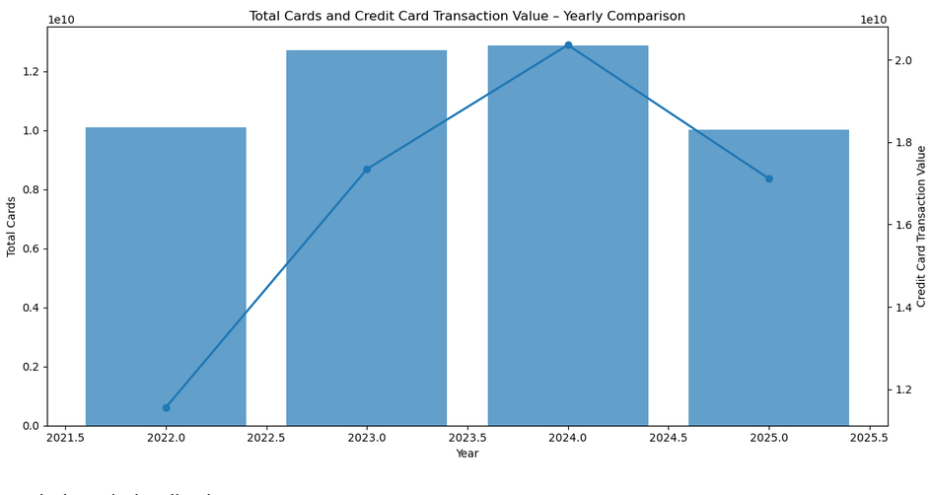

Analysis and Visualization Strategy
Analysis | Chart Type | Why This Chart Was Chosen
Credit card distribution | Histogram + KDE | Shows how frequently value ranges occur, revealing concentration, spread and skewness that summary statistics alone cannot show.
ATM/CRM infrastructure by category | Vertical bar | Compares one summed quantity across a small number of discrete groups; bar length is the clearest way to compare magnitude.
Digital payment infrastructure by category | Multi-series bar | Compares four related infrastructure variables side-by-side per category in a single view.
Card adoption by category | Grouped bar | Lets credit- and debit-card totals be compared directly within each category.
Yearly card trend | Line | Year is an ordered axis; a line makes the direction and rate of change over time immediately visible.
Monthly UPI QR trend | Line | Tracks one metric continuously at fine monthly granularity to read the pace of growth.
Top 10 banks (cards / UPI QR) | Horizontal bar | Long bank-name labels read better horizontally, and horizontal bars naturally represent a ranking.
Transaction channel composition (credit/debit) | Pie | Shows how a total (100% of transaction volume) splits into a small number of mutually exclusive parts.
Credit vs debit transaction value | Bar (2 categories) | Provides a direct magnitude comparison between exactly two totals.
Cards vs credit-card transaction value | Scatter (with hue) | Reveals the relationship between two continuous variables; colour-by-category adds a third dimension without requiring additional charts.
Credit cards by category (spread) | Box plot | Shows the full distribution, including median, spread and outliers, rather than only a single average. This is useful when the data is skewed.
Correlation across 14 indicators | Heatmap | Allows many pairwise relationships to be scanned simultaneously using colour, with exact correlation coefficients annotated.
Cards & transaction value over time | Dual-axis combo (bar + line) | Combines two metrics on very different scales, such as a count and a monetary value, on one shared time axis.
All numeric variables (outlier check) | Box plot | Directly visualizes the quartile logic (Q1, median, Q3 and whiskers) used by the numerical IQR outlier test.

8. KEY PATTERNS, CORRELATIONS & ANOMALIES
1.Public Sector Banks dominate physical ATM/CRM infrastructure, with approximately 1.76 times the infrastructure of Private Sector Banks, reflecting their strong traditional banking network.
2.Private Sector Banks have a much stronger presence in digital infrastructure, accounting for approximately 90.9% of UPI QR infrastructure Yes Bank contributes around 71.6% of the top-10 UPI QR total making it an important observation for further verification.
3.Credit-card holdings are highly skewed with the mean (~1.54 million) significantly higher than the median (11,610), indicating that a small number of large banks account for a major share of credit cards.
4.Debit-card holdings remained almost stable, declining by only 0.11% between 2023 and 2024 while credit-card holdings and transaction values continued to increase.
5.Credit-card transaction value is growing faster than the card base, suggesting that the increase in transaction value is driven not only by new cards but also by higher usage of existing cards.
6.Strong correlations were observed between debit cards and total cards (0.996) and between credit cards and credit-card transactions (0.979–0.975), indicating strong and consistent relationships among related variables.
7.Outliers were identified across all numerical variables with the highest number in dc_pay_trns_other_val (610 records, ~22.8%) and the lowest in cc_pay_trns_other_val (139 records, ~5.2%). These were retained as they are more likely to reflect genuine differences in transaction scale across banks rather than data-entry errors.

9. CONCLUSION
This analysis of RBI bank-wise ATM/POS/card statistics (2,671 bank-month records, 67 banks, March 2022–September 2025) confirms a clear, ongoing shift in India's retail payments landscape from cash-based to card- and QR-based digital payments. Physical infrastructure remains concentrated in large, traditional Public Sector Banks, while digital (UPI QR) infrastructure is even more concentrated within Private Sector Banks — and within one bank in particular. Credit-card adoption and transaction value are still growing at a healthy pace, while debit-card holdings appear to be approaching saturation. The strong correlations among related indicators confirm the underlying data and derived features are internally consistent, while the moderate correlation between card count and transaction value shows growth is increasingly driven by usage, not just issuance.

10. RECOMMENDATIONS
1.The high concentration of UPI QR infrastructure in a single bank should be further investigated to determine whether it reflects actual market leadership or differences in reporting and measurement.
2.Greater focus should be placed on credit-card growth, as debit-card holdings have remained relatively stable, while credit-card holdings and transaction values have continued to increase.
3.Small Finance Banks, Payment Banks, and Foreign Banks should be encouraged to expand their digital payment infrastructure, as these categories show greater potential for growth.
4.The identified outliers should be retained and used for bank segmentation and benchmarking, as they may represent genuine differences in bank size and transaction volumes rather than data errors.
5.POS and online transaction patterns should be monitored by card type to support better infrastructure planning, with continued POS/ATM investment for debit cards and greater emphasis on digital and online channels for credit cards.

